Software Requirements Specification Template

Pick The Best Project

Software Requirements Specification

Version 1.0

06/02/2022

Deepthi Kaithi S545119
Vikram Thakkallapally S545251
Lakshmi Sireesha Pavalla S543026
Sai Nikhil Vadiyapu S545522
Vinayaka Reddy Jogannagari S545029

Submitted in partial fulfilment
Of the requirements of
CSIS 44-691 Graduate Directed Project 1

Revision History

Date | Description | Author | Comments
<date> | <Version 1> | <Your Name> | <First Revision>

Document Approval

The following Software Requirements Specification has been accepted and approved by the following:
Signature | Printed Name | Title | Date

Table of Contents

Table of Contents Page Number

- Introduction
  - Purpose
  - Scope
  - Definitions, Acronyms, and Abbreviations
  - References
  - Overview
- General Description
  - Product Perspective
  - Product Functions
  - User Characteristics
  - General Constraints
  - Assumptions and Dependencies
- Specific Requirements
  - External Interface Requirements
    - User Interfaces
    - Hardware Interfaces
    - Software Interfaces
    - Communications Interface
  - Functional Requirements
  - Use Cases
  - Class/Objects
  - Non-Functional Requirements
3.5.1. Performance
3.5.2. Reliability
    - Availability
    - Security
    - Portability
  - Inverse Requirements
  - Design Constraints
  - Logical Database Requirements
  - Other Requirements
  - Prototypes (for complete project)
  - Use Case Diagrams
- Design
4.1. ER diagram
4.2. GUI
- Analysis Models
5.1. Data Flow Diagram
5.2. Sequence Diagram

1.Introduction
1.1 Purpose
Purpose of our project is to develop a single website which indeed show results from various websites.
1.2 Scope
Main Scope of our project is to provide a easy way of access to customers.

2.General Description
Our Project is developing a web application where user can find price of a particular product across various applications at one place.
For Example, A shoe product from Amazon, E-bay, Costco, Kroger etc. are viewed and compared in a single website.
Here we are also planning to involve the process of authenticating the users, so that only authorized or registered users can have access to our application.

3.Specific Requirements

3.1.External Interface Requirements
We will be having external e-commerce websites containing the information about products.

3.1.1. User Interfaces
We are designing user interface with the help of Angular JS.

3.1.2. Hardware Interfaces
We need a good laptop or computer with good ram capacity and continuous internet.

3.1.3. Software Interfaces
The software’s needed are the eclipse, Spring-Boot, Oracle SQL developer.

3.1.4. Communications Interface
The Communication Interface we are using for our project is HTTPS services.

3.2. Functional Requirements

Customer side: -
- Ability to Sign up/Login into the website.
- Ability to Search for the Product after successfully logging in.
- Ability to View the Product Results from various websites.
- Ability to Choose the best available product, according to the price.
- Ability to redirect to the external website based on the provided URL.
Administration side: -
- Ability to Login in the user
- Ability to Display error message
- Ability to Display the product which user is referring or searching for.
- Ability to add a message for the user if the referred product is not available in our website.
- Ability to add the new products into our memory unit on a regular basis.
3.5 NON-FUNCTIONAL REQUIREMENTS
Performance
Web performance is the objective measurement and perceived user experience of a web site or application. This includes the following major areas:
  - Reducing overall load time
  - Making the site usable as soon as possible
  - Smoothness and interactivity
Reliability
In web application Reliability is the main concern. It basically have the factors which makes web application strong, usable, mature and effective. It deals with the rate of failure in web application.

Availability
Website availability (also called website uptime) refers to the ability of the users to access and use a website or web service. A website’s availability is typically communicated as a percentage for a given span of time.
Security
Web application security refers to a variety of processes, technologies, or methods for protecting web servers, web applications, and web services such as APIs from attack by Internet-based threats.

3.3. Use Cases

In this Project the primary goal of Pick the Best App is to provide all the product details such as price and rating of the product from the various websites like Amazon, E-Bay, Costco, Kroger etc. on a single website, which indeed helps the customers to save their valuable time.

-
3.4. Class/Objects

We will create the classes accordingly once we start implementation of the project.

- Design.

  - ER Diagram

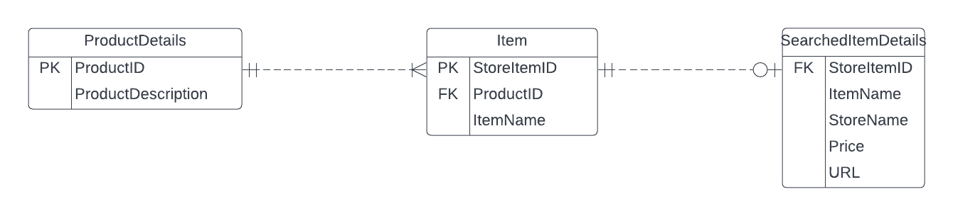

  - GUI

SCREEN 1

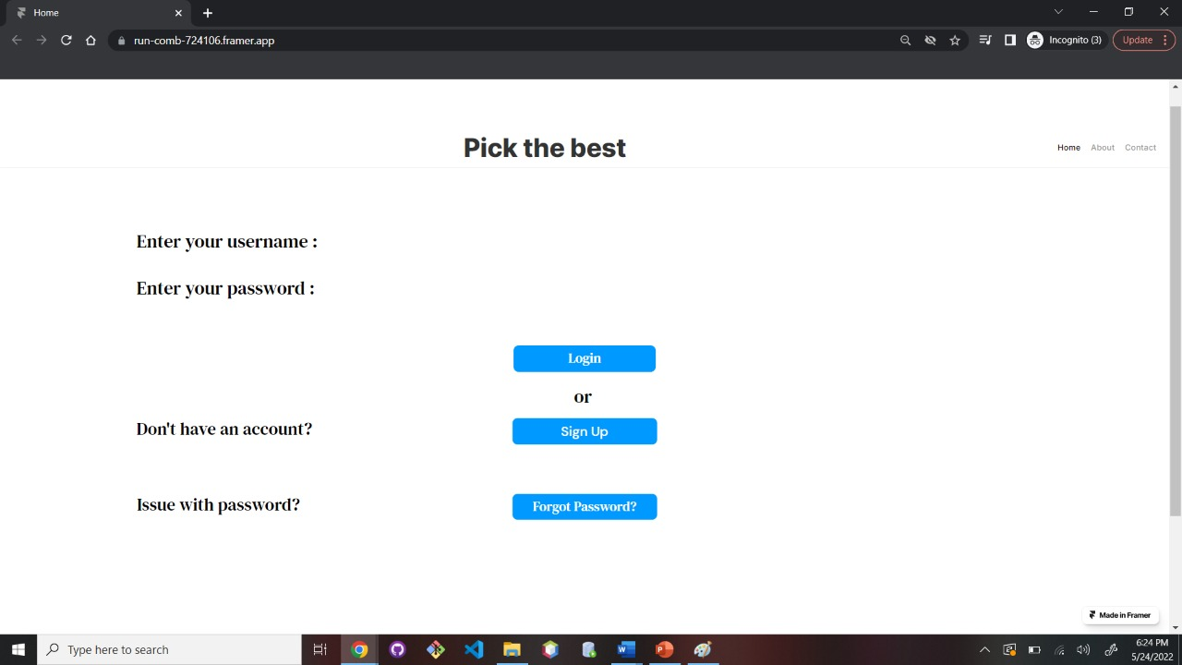

SCREEN 2

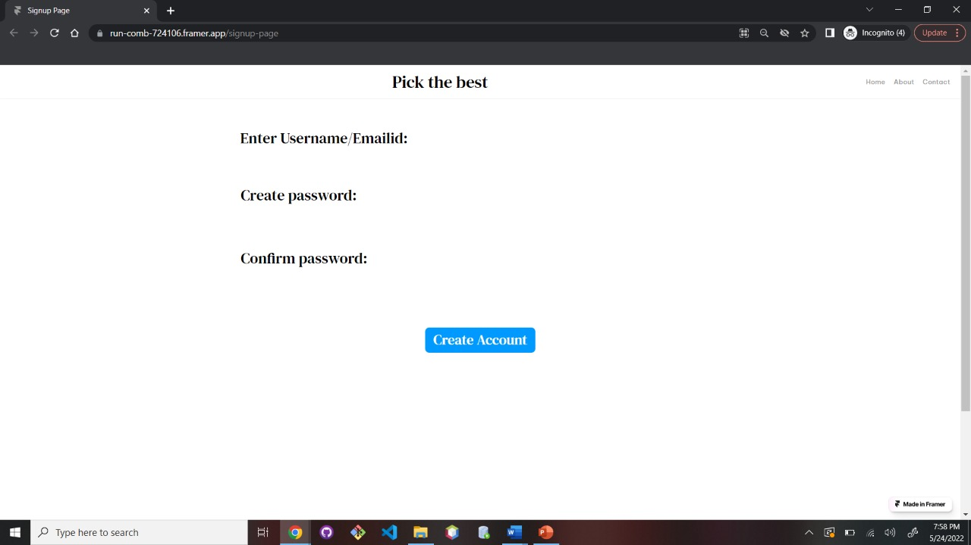

SCREEN 3

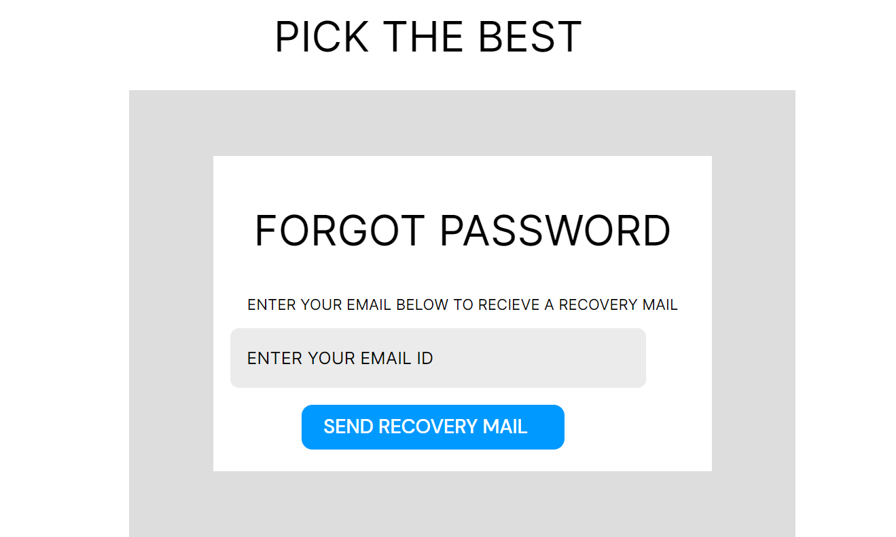

SCREEN 4

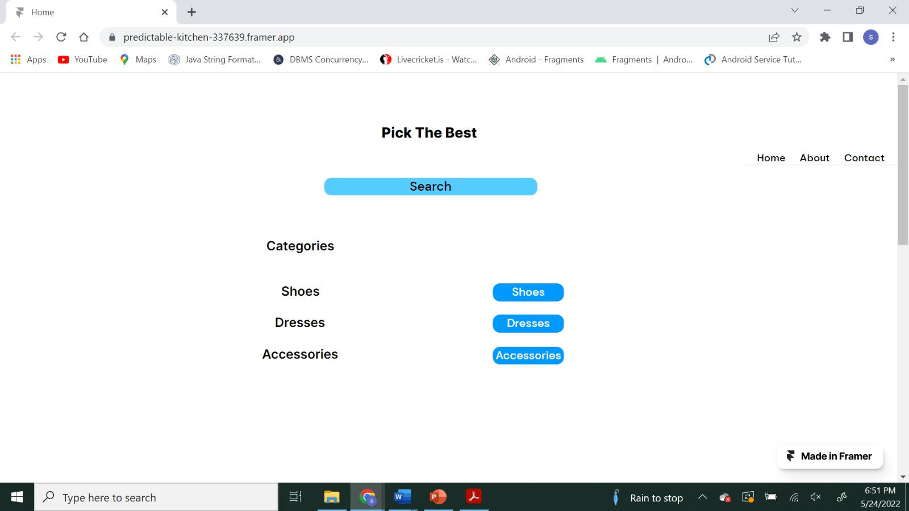

SCREEN 5

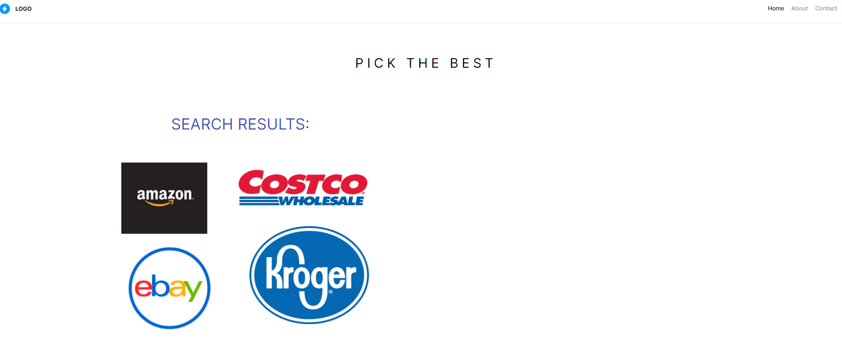

  - Data Flow Diagram
